SWE314 : Software Security Engineering

Assignment #2 – Integration of security in the SDLC

Contents
1. Introduction 3
1.2 Functional Requirements 3
1.3 Non-Functional Requirements 4
2. Use-Case Diagram 5
3. Requirement Analysis 5
3.1 Countermeasures 7
4. Misuse-Case Diagram 8
4.1 Misuse-Case Descriptions 9
5. Secure System Architecture 11
7. System implementation 14
8. Security Testing Strategy and Test Plan 19
9. Summary 20

1. Introduction
This project report documents the development of a Secure Customer Banking System, designed with a primary focus on integrating security engineering principles throughout the Software Development Life Cycle (SDLC). As financial institutions increasingly rely on digital platforms, the need for robust security, high availability, and data privacy has become crucial. The proposed system aims to provide customers with essential banking functionalities such as online account opening, fund transfers, and profile management, while strictly adhering to critical security requirements defined by the bank's representatives.

The objective of this report is to demonstrate how security is built into the system from the ground up. This includes the identification of functional and non-functional requirements with a specific emphasis on constraints such as confidentiality, integrity, and role-based access control. The report further details the threat modeling process using Misuse Case diagrams to identify potential risks , followed by the architectural and design choices made to mitigate these threats. Finally, it outlines the implementation and testing strategies employed to ensure the effectiveness of the security measures

1.2 Functional Requirements
- 1.2.1 The customer shall be able to log in to the system and open a bank account online.
- 1.2.2 The customer shall be able to view account information, including profile details, transaction history, and the remaining balance.
- 1.2.3 The customer shall be able to perform bill payments online.
- 1.2.4 The customer shall be able to transfer funds to other local, national, or international accounts.
- 1.2.5 The customer shall be able to send and receive messages, enquiries, or requests to the bank.
- 1.2.6 The customer shall be able to print account statements for a specific period of time.
- 1.2.7 The customer shall be able to update their profile information, specifically their phone number, address, and job/salary information (Upload of proof required).
- 1.2.8 The Clerk shall be able to view current customer data only.
- 1.2.9 The Director shall be able to view all customer data, including past transactions, but shall not be able to modify it.
- 1.2.10 The Branch Manager shall be able to modify data related to a customer.
- 1.2.11 The system shall retain all historical customer data for a period of 3 years.
- 1.2.12 The system shall automatically archive data that is older than 3 years.
- 1.2.13 The system shall prevent any user from deleting data related to customers.

1.3 Non-Functional Requirements
- 1.3.1 The system shall be available to users at all times.
- 1.3.2 The system shall restrict maintenance activities to the hours between 1:00 AM and 6:00 AM.
- 1.3.3 The system shall restrict access to information based on employee groups, ensuring not all employees have access to every part of the system.
- 1.3.4 The system shall implement measures to avoid identity theft and prevent malicious user access.
- 1.3.5 The system shall validate all data input to prevent misuse.
- 1.3.6 The system shall guarantee the confidentiality of sensitive information, including customer identity, transactions, and amounts.
- 1.3.7 The system shall preserve information integrity in all cases.
- 1.3.8 The system shall guarantee anonymity for customers who desire it, handling identifying information (name, ID, phone) with caution.
- 1.3.9 The system shall be friendly and easy for customers to use.
- 1.3.10 The system shall be accessible from multiple device types, including desktops, laptops, tablets, and smartphones.
- 1.3.11 The system shall be reliable enough to ensure consistent operation.
- 1.3.12 The system shall be designed to allow for maintenance with the lowest possible effort, time, and cost.

2. Use-Case Diagram
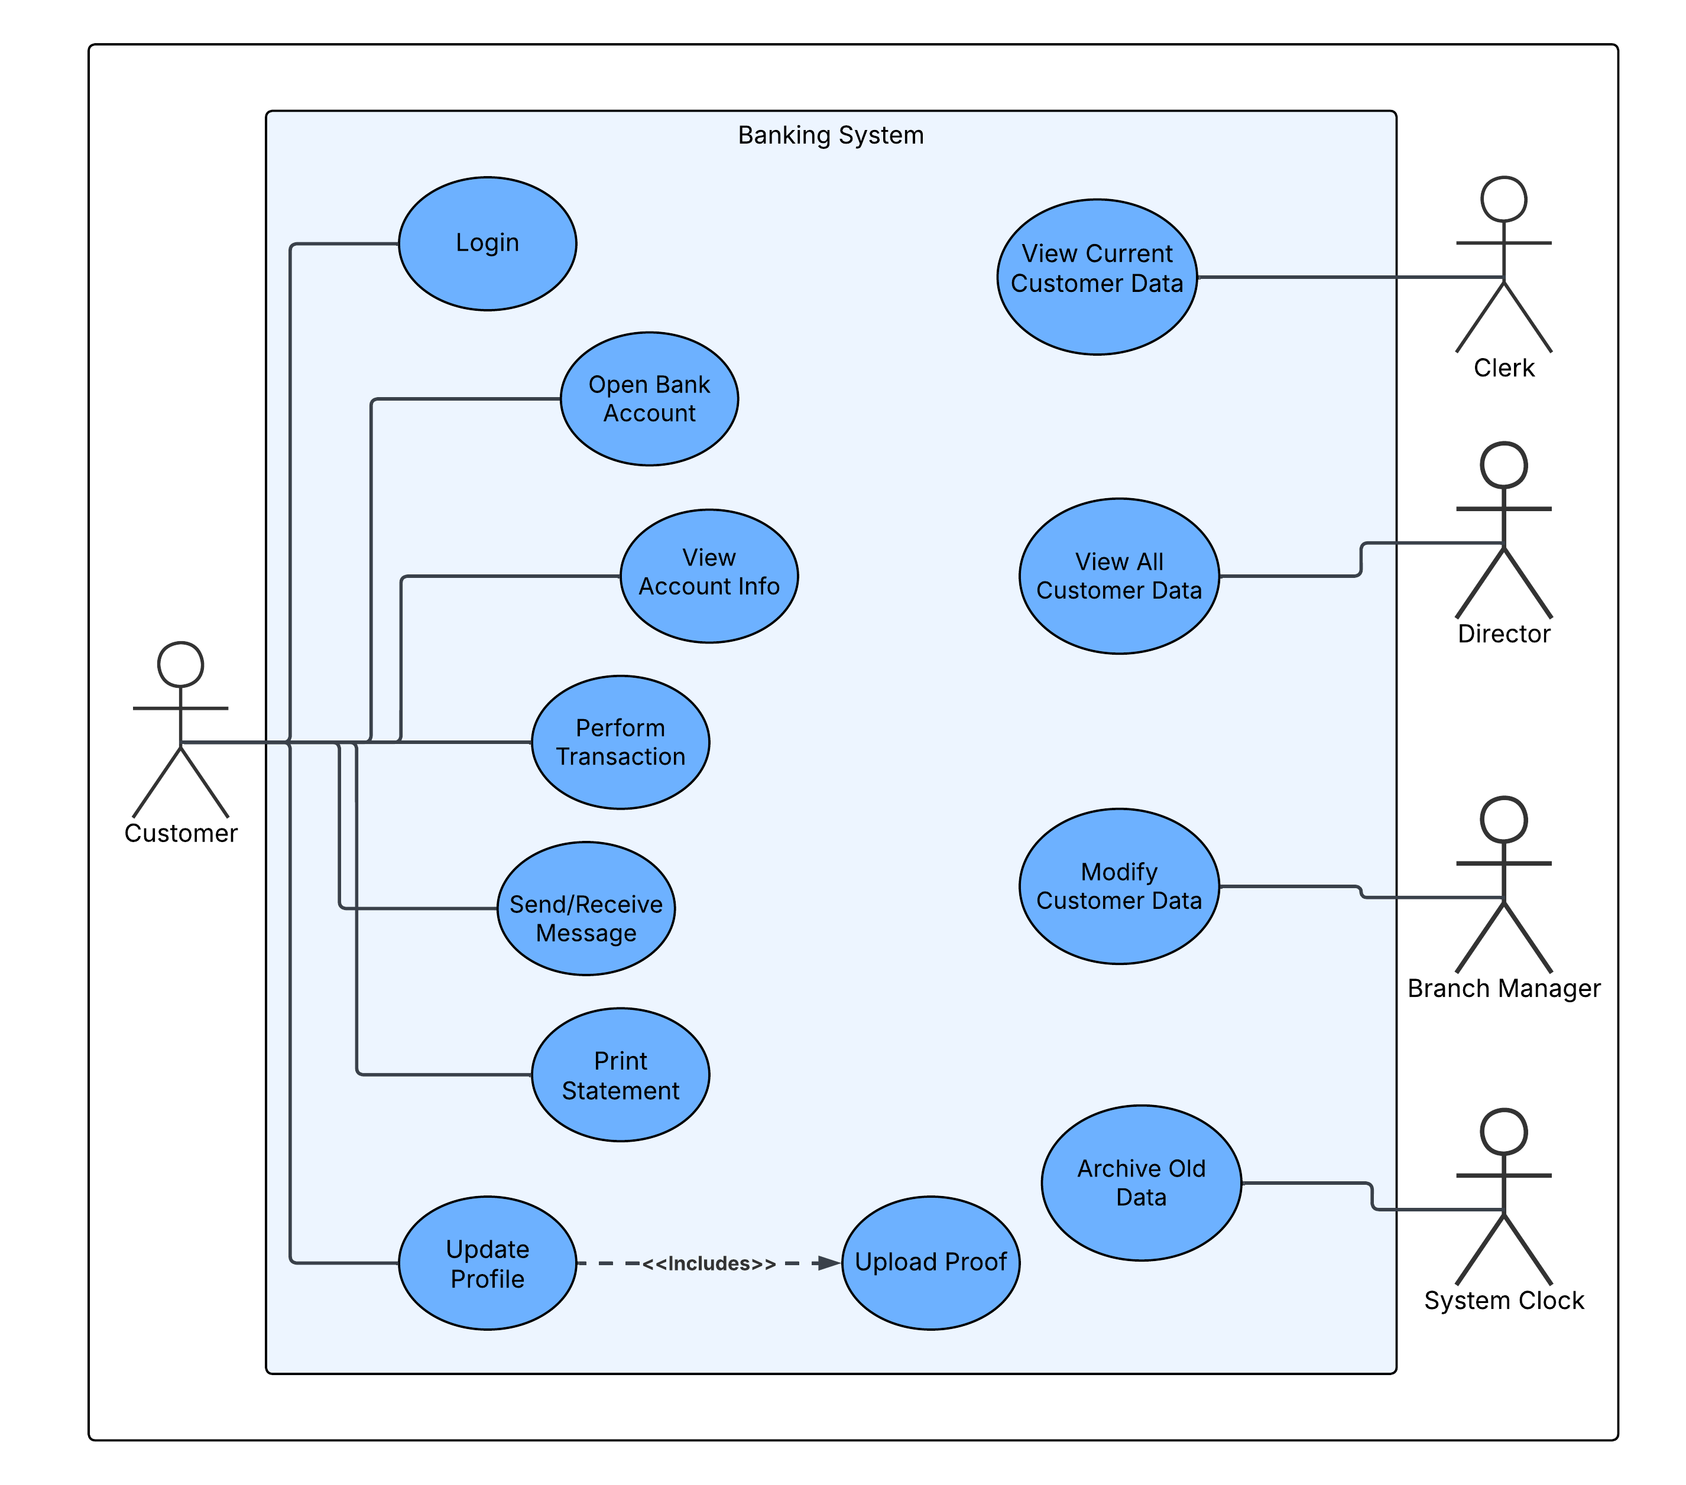

3. Requirement Analysis
- 1.2.1 The customer shall be able to log in to the system and open a bank account online.
Fail Case: A malicious user bypasses the login or guesses a customer's credentials.
Consequences of failure: Unauthorized access to funds and private data.
Associated risks/threats: Risk of Identity Theft / Account Takeover: Attackers perform actions as the user.

- 1.2.3 The customer shall be able to perform bill payments online.
Fail Case: A transaction is intercepted and modified in transit (ex: changing the recipient account).
- Consequences of failure: Customer loses money; Bank is liable for financial loss.
- Associated risks/threats: Risk of Man-in-the-Middle (MitM) Attack: Integrity of the transaction is violated.

- 1.2.7 The customer shall be able to update their profile information, specifically their phone number, address, and job/salary information (Upload of proof required).
Fail Case: A malicious user changes the phone number or address without proper verification.
Consequences of failure: Account recovery or OTPs are sent to the attacker.
Associated risks/threats: Risk of Privilege Abuse: Attacker takes over account control mechanisms.

- 1.3.5 The system shall validate all data input to prevent misuse.
Fail Case: The system accepts malicious scripts or SQL commands in the "Message" or "Update Profile" fields.
Consequences of failure: The database is compromised, or data is leaked/deleted.
Associated risks/threats: Privilege: Risk of SQL Injection: Database compromise or malicious scripts executing on client devices.

- 1.3.3 The system shall restrict access to information based on employee groups, ensuring not all employees have access to every part of the system.
Fail Case: A Clerk accesses historical data, or a Director modifies customer data.
Consequences of failure: Privacy violation and potential data corruption.
Associated risks/threats: Privilege: Risk of Insider privilege abuse: Employees accessing data beyond their authorization.

- 1.3.1 The system shall be available to users at all times.
Fail Case: The system goes down during peak daytime hours due to high traffic or attack.
Consequences of failure: Customers cannot transact, loss of reputation and business.
Associated risks/threats: Privilege: Risk of Denial of Service (DoS): Malicious traffic overwhelms the system.

- 1.3.8 The system shall guarantee anonymity for customers who desire it, handling identifying information (name, ID, phone) with caution.
Fail Case: Identifying information (Name, ID) is displayed or stored in cleartext for anonymous accounts.
Consequences of failure: Identity of the anonymous customer is revealed.
Associated risks/threats: Privilege: Risk of Privacy Violation / Data Leakage: Breach of confidentiality terms.

3.1 Countermeasures
- Risk/Threat: Identity Theft / Account Takeover
Countermeasure: Multi-Factor Authentication: Require a code sent to a phone/email in addition to a password for login and sensitive actions.
Fix Type: Internal (Implemented in code/logic).

- Risk/Threat: Man-in-the-Middle (MitM) Attack
Countermeasure: Encryption and Digital Signatures: Encrypt all traffic. Use hashing/signing to ensure transaction data isn't altered during transit.
Fix Type: Internal (Protocol implementation).

- Risk/Threat: SQL Injection
Countermeasure: Input Sanitization and Parameterized Queries: Validate all inputs against a strict whitelist (ex: no special characters).
Use prepared statements for Data Base queries.
Fix Type: Internal (Code implementation).

- Risk/Threat: Privilege Abuse
Countermeasure: Strict Role Based Access Control and Audit Logging: Implement Role-Based Access Control in the code. Log every access and modification attempt (who, what, when) for audit trails.
Fix Type: Internal (Code/Design implementation).

- Risk/Threat: Denial of Service (DoS)
Countermeasure: Firewalls: Use external filtering services to detect and block malicious traffic spikes before they hit the servers.
Fix Type: External (Infrastructure/Network).

- Risk/Threat: Privacy Violation / Data Leakage
Countermeasure: Data Masking/Encryption: Encrypt sensitive columns (Name, ID) in the database. Mask these fields on the UI for unauthorized roles.
Fix Type: Internal (Design/Data Base implementation).

4. Misuse-Case Diagram
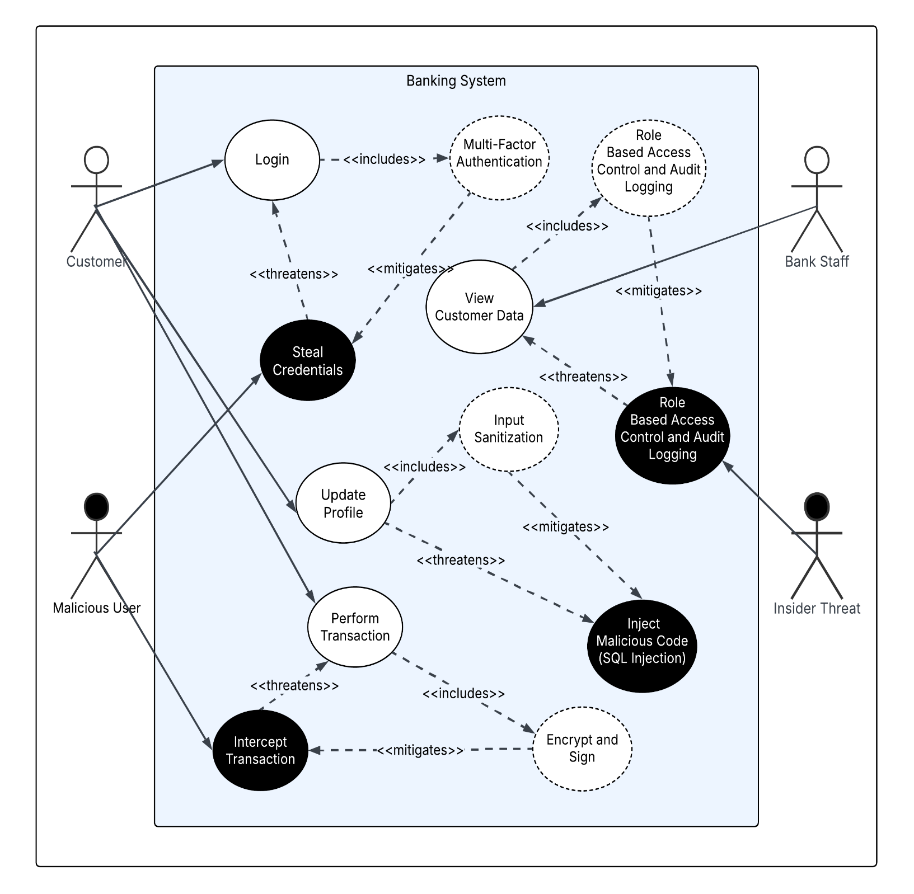

4.1 Misuse-Case Descriptions

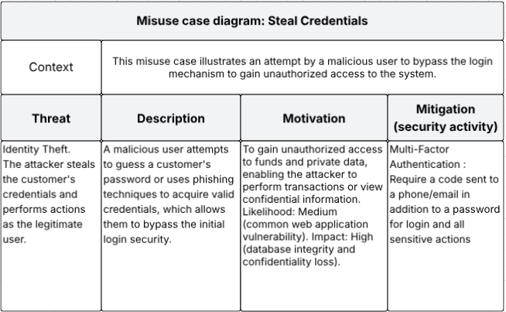

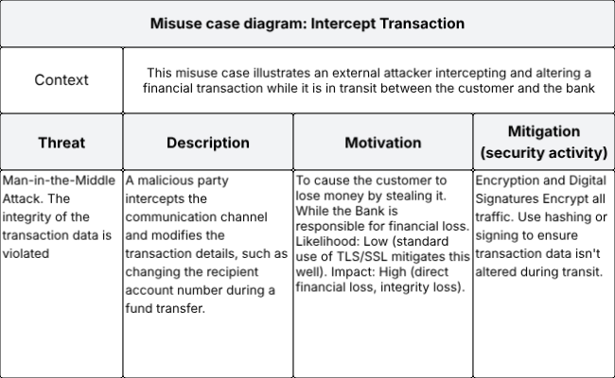

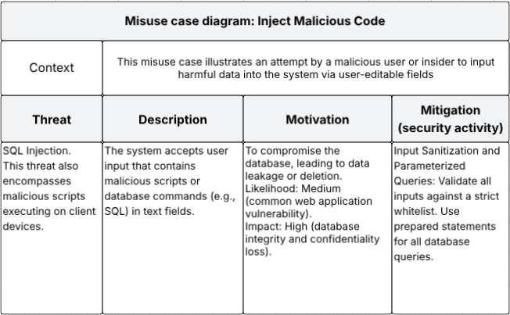

5. Secure System Architecture

In this project, we selected the 3-Tier Architecture because it provides clear separation of responsibilities between the Presentation Layer, the Application/Business Layer, and the Data Layer. This separation makes it easier to enforce security controls and to analyze the threats that are specific to this architectural style.

The following security threats are commonly associated with 3-Tier systems. For each threat, we verified whether the mitigation was already implemented in previous sections. If the mitigation was already addressed earlier in the report, it is referenced here along with whether it is considered an internal or external solution.

1. Eavesdropping on communication between tiers
Threat: An attacker may intercept data transmitted between the client and the application server, or between the application layer and the database.
Mitigation: This threat was already mitigated using full TLS/HTTPS encryption to protect confidentiality and integrity of transmitted data.
Fix Type: Internal.

2. Man-in-the-Middle (MitM) attacks
Threat: A malicious actor may intercept and alter transactions during communication across tiers.
Mitigation: This threat was previously addressed through encryption, hashing, and signing of sensitive transaction data as described earlier.
Fix Type: Internal.

3. SQL Injection targeting the Application → Data Layer boundary
Threat: The application server may unintentionally pass malicious SQL to the database.
Mitigation: This threat was mitigated earlier through strict input validation and the use of parameterized queries.
Fix Type: Internal.

4. Privilege Abuse within the Application Layer
Threat: Insiders such as employees may access or modify data beyond their assigned roles.
Mitigation: Role-Based Access Control (RBAC) combined with audit logging was previously implemented to restrict and monitor employee actions.
Fix Type: Internal.

5. Denial of Service (DoS) attacks on the Application Layer
Threat: Large volumes of malicious traffic may overwhelm the application tier, affecting system availability.
Mitigation: DoS attacks were already mitigated using external firewalls and traffic-filtering mechanisms to block malicious requests before reaching the server.
Fix Type: External.

6. Data Leakage in the Database Layer
Threat: Sensitive customer information stored in the data tier may be exposed if the database is compromised.
Mitigation: This threat was previously addressed using encryption at rest and data masking to limit exposure of sensitive fields.
Fix Type: Internal.

7. Privacy Violations involving anonymous customers
Threat: Identifying information may unintentionally appear in cleartext for accounts that require anonymity.
Mitigation: This requirement was already mitigated using cautious handling and masking of identifying fields in both the application and database layers.
Fix Type: Internal.

Based on the analysis above, all major threats associated with the chosen 3-Tier Architecture were already mitigated in earlier sections of the report. Therefore, no new countermeasures were needed at this stage. The layered design of the selected architecture supports the applied security controls by ensuring that each tier enforces protections appropriate to its role in the system.

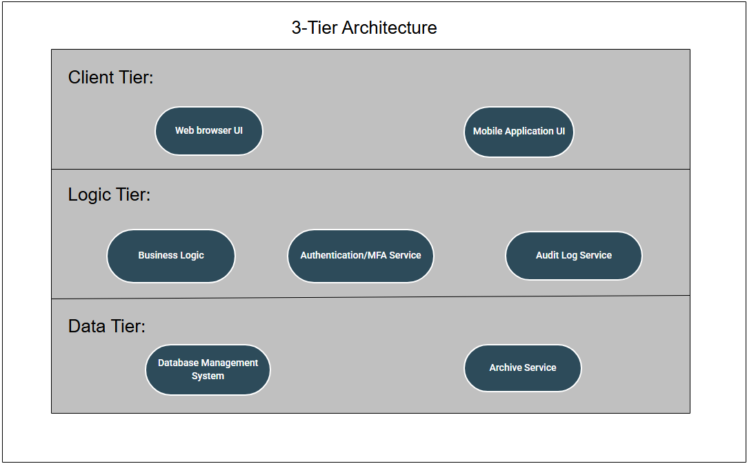

6. Class-Diagram
In designing the Secure Customer Banking System, we adhered to Object-Oriented Design (OOD) principles and utilized the 3-Tier Architecture described in Section 5. Our primary objective was to decouple data (Entity Classes) from business logic (Control Classes) to ensure a modular, maintainable, and secure system structure.

Classification of Classes: To maintain system manageability and separation of concerns, the classes were categorized into three distinct stereotypes:
- Entity Classes (Data): These classes are responsible for holding system data. We defined a User class to manage shared login credentials and role information, along with distinct Customer and Account classes to handle sensitive banking details securely.
- Control Classes (Logic): Business logic was distributed among specific controllers, such as TransactionController and SupportService. This separation ensures that each class focuses on a single responsibility (Single Responsibility Principle), resulting in cleaner code and a reduced attack surface compared to using a single monolithic controller.
- Interface Classes (Boundary): These classes manage the interaction between the external user and the system. They define the entry points and methods invoked by the User Interface, such as login() and viewProfile().

Security Integration in Design: Specific design decisions were implemented to integrate the security countermeasures proposed in Section 3 directly into the system architecture:
- Encapsulation: Critical attributes within the Customer and Account classes were defined as private (indicated by a -). This adheres to the principle of "least privilege," ensuring that external components cannot directly modify internal state without going through authorized methods.
- Encryption: To mitigate data leakage risks, the design dictates that the Customer class stores sensitive information in an encrypted format. Attributes were explicitly named with an prefix (e.g., enc_NationalID, enc_Name) to clearly indicate that they are not stored as plain text.
- MFA Implementation: To mitigate identity theft, a verifyMFA(code: int) method was incorporated into the design. This facilitates the Multi-Factor Authentication requirement by validating a secondary token following successful password authentication.
- Audit Logging: An AuditLogger class was introduced to support accountability. Control classes utilize this component to generate immutable records of user actions (who, what, and when), thereby preventing privilege abuse.
- Transaction Integrity: Payment processing logic was centralized within the TransactionController. This centralization allows for consistent input validation and fraud detection checks to be performed in a single, secure location before any funds are transferred.

Example of a class diagram for the System:

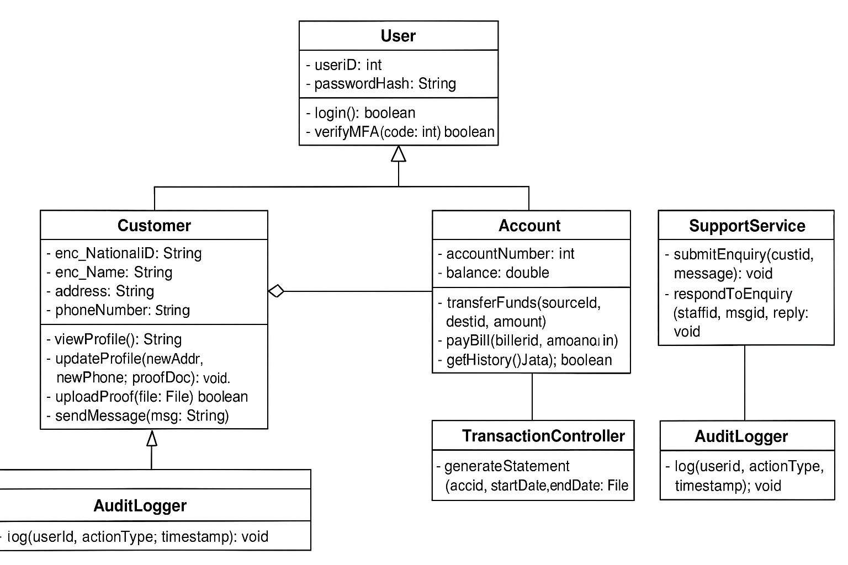

7. System implementation
For the following implemented classes we used our Phase 1 Codebase for Encryption purposes, we implemented the following two classes: SecureUser and BankingSystem.

SecureUser
This class represents the user entity. It relies on EncryptionManager to secure its data upon creation.

public class SecureUser {
private String username;
private String securedPassword; // Stored as ciphertext using Vigenere
private String role; // "CUSTOMER", "CLERK", "DIRECTOR"
private String encryptedNationalID; // Stored as ciphertext using DES

// Pass the manager in to handle the initial encryption
public SecureUser(String username, String plainPassword, String role, String nationalID, EncryptionManager manager) {
this.username = username;
this.role = role;

// MITIGATION 1: AUTHENTICATION (Password Protection)
// We use Vigenere from the uploaded classes to obfuscate the password
manager.selectAlgorithm("vigenere");
this.securedPassword = manager.encrypt(plainPassword);

// MITIGATION 2: ENCRYPTION (Confidentiality)
// We use DES from the uploaded classes to encrypt sensitive personal data
manager.selectAlgorithm("des");
this.encryptedNationalID = manager.encrypt(nationalID);
}

public String getUsername() {
return username;
}

public String getRole() {
return role;
}

public String getSecuredPassword() {
return securedPassword;
}

public String getEncryptedNationalID() {
return encryptedNationalID;
}
}

BankingSystem
This is the main control class. It implements Authentication Logic, RBAC, and Input Validation while utilizing the EncryptionManager to handle the cryptographic operations.

public class BankingSystem {
private Map<String, SecureUser> database = new HashMap<>();
private SecureUser currentUser;
// Use the EncryptionManager provided in your project files
private EncryptionManager securityModule = new EncryptionManager();

public void addUser(String username, String password, String role, String nationalID) {
// Create user (Encryption happens inside the constructor using the manager)
SecureUser user = new SecureUser(username, password, role, nationalID, securityModule);
database.put(username, user);
}

// --- MITIGATION: AUTHENTICATION ---
public boolean login(String username, String password) {
SecureUser user = database.get(username);

if (user != null) {
// Re-encrypt the input password using the same algorithm (Vigenere) to compare
securityModule.selectAlgorithm("vigenere");
String inputObfuscated = securityModule.encrypt(password);

if (user.getSecuredPassword().equals(inputObfuscated)) {
this.currentUser = user;
System.out.println(">> Login Successful: Welcome " + user.getRole() + " " + user.getUsername());
return true;
}
}
System.out.println(">> Login Failed: Invalid Credentials.");
return false;
}

// --- MITIGATION: ROLE-BASED ACCESS CONTROL (RBAC) & ENCRYPTION ---
public void viewSensitiveData(String targetUsername) {
if (currentUser == null) {
System.out.println("Error: Please login first.");
return;
}

// Rule: Only DIRECTORS or the User THEMSELVES can view National ID
if (currentUser.getRole().equals("DIRECTOR") || currentUser.getUsername().equals(targetUsername)) {
SecureUser target = database.get(targetUsername);
if (target != null) {
// Decrypt the data using DES
securityModule.selectAlgorithm("des");
String decryptedID = securityModule.decrypt(target.getEncryptedNationalID());
System.out.println(">> Access Granted. Decrypted National ID for " + targetUsername + ": " + decryptedID);
} else {
System.out.println(">> User not found.");
}
} else {
System.out.println(">> Access Denied: Role '" + currentUser.getRole() + "' is not authorized to view sensitive data.");
}
}

// --- MITIGATION: INPUT SANITIZATION ---
public void updateProfile(String newAddress) {
if (currentUser == null) return;

// Simple validation rule: No special characters that could imply Injection (;, <, >, ')
if (newAddress.matches(".*[<>;\"'].*") || newAddress.toLowerCase().contains("drop")) {
System.out.println(">> SECURITY ALERT: Malicious input detected! Profile update blocked.");
} else {
System.out.println(">> Success: Profile address updated to: " + newAddress);
}

}}

Execution Screens: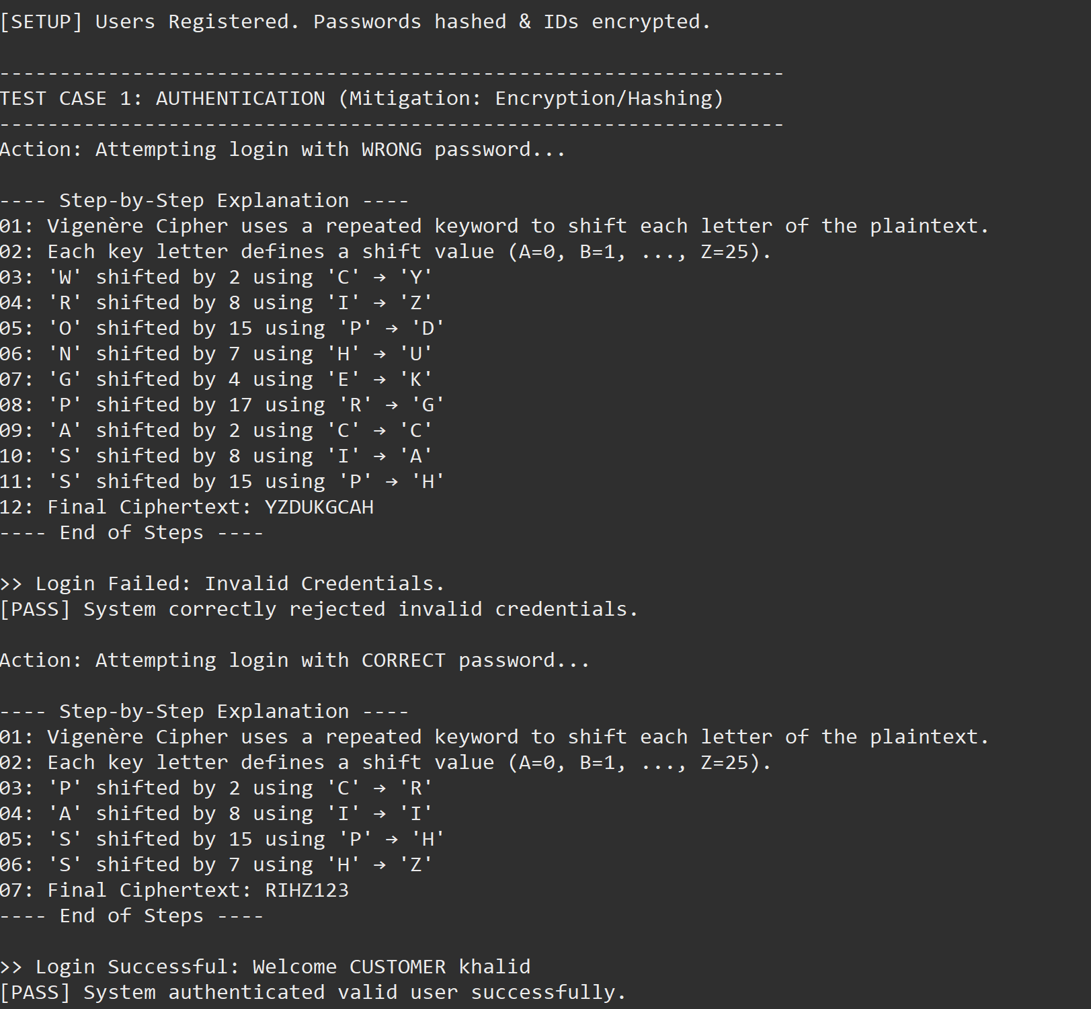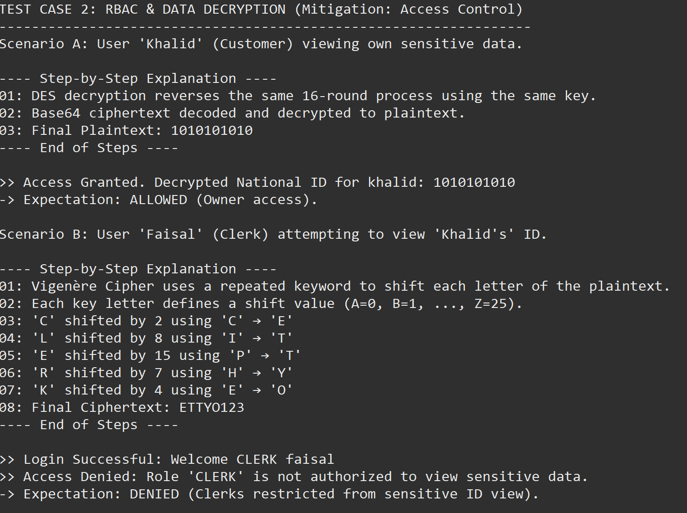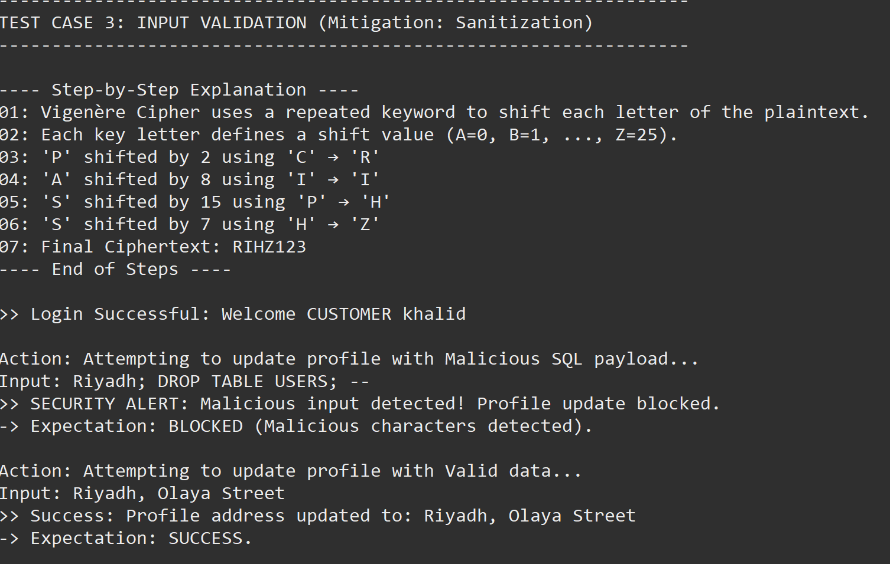

8. Security Testing Strategy and Test Plan
The testing strategy for this system is based on three main security-focused activities designed to verify the effectiveness of the implemented mitigation techniques: code review, functional testing, and penetration testing.

First, we would conduct code reviews focusing on the security-related parts of the system, such as authentication, authorization, input validation, and database queries. The goal of the code review is to verify that the mitigation techniques we described earlier are correctly implemented in the code.

Second, we would perform normal functional testing to ensure that the system behaves correctly under expected conditions. This includes testing login, role restrictions, profile updates, transactions, and validation of incorrect or malicious inputs to confirm they are handled safely.

Finally, we would perform penetration testing to simulate real attacker behavior. This would include trying SQL injections, attempting to bypass authentication, checking whether communication is really encrypted, and testing access control boundaries between different user roles. The purpose of penetration testing is to confirm whether the security countermeasures are sufficient in practice.

Together, these three testing methods, code review, functional testing, and penetration testing provide a comprehensive evaluation of whether the implemented mitigations effectively strengthen the security of the system.

9. Summary
This report documents the end-to-end development of a Secure Customer Banking System, demonstrating the practical integration of security engineering principles into the Software Development Life Cycle (SDLC). The primary objective was to design a system that not only delivers essential banking functionalities, such as fund transfers, profile management, and account administration but also inherently mitigates critical security risks including identity theft, data leakage, and unauthorized access.

The project began with a detailed analysis of Functional and Non-Functional Requirements, establishing a baseline for expected system behavior and mandatory security constraints like confidentiality, integrity, and high availability. To proactively identify threats, we employed Misuse Case Modeling, visualizing how malicious actors (both external hackers and internal threats) could attack the system. This analysis led to the definition of specific countermeasures, including Multi-Factor Authentication (MFA), Input Sanitization, and Role-Based Access Control (RBAC).

Architecturally, the system adopts a 3-Tier Architecture (Presentation, Application, Data) to ensure a clear separation of concerns, which simplifies the enforcement of security policies. The design phase utilized Object-Oriented Design (OOD) principles to create a secure class structure, featuring encapsulated attributes and dedicated security control classes.

The system's core security features were validated through a Java-based implementation, utilizing cryptographic algorithms (Vigenere and DES) to secure user credentials and sensitive national identity data. Finally, a robust Security Testing Strategy was defined, combining code reviews, functional testing, and penetration testing to verify the effectiveness of the implemented mitigations.

In conclusion, this project illustrates that by addressing security at every stage, from requirements gathering to implementation and testing a banking system can be made resilient against modern cyber threats while maintaining usability and performance for its customers.

